Tessella Project Number: 6466
Tessella plc 26 The Quadrant, Abingdon Science Park, Abingdon, Oxfordshire, OX14 3YS, UK
T: +44 (0)1235 555511 | F: +44 (0)1235 553301 | E: info@tessella.com | www.tessella.com

Client: STFC & ORNL
Mantid
PM report to Project Management Board
2nd December 2010



Document Control
This document is under document control. All members of the distribution list will receive updated copies whenever alterations are made. All other copies are uncontrolled.

Contributors
Name | Role | Company
Nicholas Draper | Author | Tessella

Document Approval
Name | Role | Company

Distribution
Name | Role | Company
Project Management Board Members | Recipient | STFC
Mantid Project Repository | Filing | STFC

Revision History
Author | Issue | Date | Description
Nicholas Draper | V1.R1.M0 | 29-Nov-2010 | 1st version written

References
Document | Ref | Date | Details and Version
Short, Medium and long term requirements from ISIS Instrument groups | [SML REQ]] | 04-Aug-2009 | http://svn.mantidproject.org/mantid/trunk/Documents/Requirements/ShortMedLong%20Aug%2009.xls
Project Specification | [PS] |  | http://svn.mantidproject.org/mantid/trunk/Documents/Project%20Management/ProjectSpecification.doc
Stakeholder Plan | [SP] |  | http://svn.mantidproject.org/mantid/trunk/Documents/Project%20Management/StakeholderPlan.doc
Risk Register | [RR] |  | http://svn.mantidproject.org/mantid/trunk/Documents/Project%20Management/RiskRegister.xls
ORNL SDAG resource plan | [SDAG-RP] |  | http://svn.mantidproject.org/mantid/trunk/Documents/Project%20Management/ORNL_SDAG_work_plan.ppt

Table of Contents
1 Introduction 4
1.1 Purpose of this Document 4
1.2 Scope of this Document 4
1.3 Context of this Issue 4
2 Project Documentation 4
3 Project Status 4
3.1 Development Progress 4
3.2 Project Uptake 10
4 Supporting Mantid 13
4.1 Current Process 13
4.2 Training 13
4.3 Next 12 months 13
5 Financial review 13
6 Citing Mantid 13
6.1 Approach 13
6.2 Mantid DoI’s 13
7 Immediate Priorities 14
7.1 Common 14
7.2 ISIS 15
7.3 SNS & HFIR 16
8 Future requirements 16
8.1 ISIS: Requirements in the short, medium and long term 16
8.2 SNS 16
9 Future Release Dates 17
10 Possible Collaborating With Other Facilities 17
10.1 Interest from other institutions 17

Introduction

Purpose of this Document
This report details the current state of the Mantid project and summarises the current plans for further development. The project management board will use the information in this report as a basis for the meeting.

Scope of this Document
The scope of this document is limited to the Mantid project, both for progress up to the meeting of the Project management board, and plans for the future.

Context of this Issue
This is the fourth project management report to the Mantid project management board and will provide input to the fourth meeting.

Project Documentation
The project documentation is available through the links below. These documents have not been changed since the last PMB meeting.
- Project Specification:
http://svn.mantidproject.org/mantid/trunk/Documents/Project%20Management/ProjectSpecification.doc
- Stakeholder Plan:
http://svn.mantidproject.org/mantid/trunk/Documents/Project%20Management/StakeholderPlan.doc
- Risk Register:
http://svn.mantidproject.org/mantid/trunk/Documents/Project%20Management/RiskRegister.xls

Project Status

Development Progress
Since the last PMB meeting in July 2010 we have completed two full development iterations and released new versions of Mantid on the following dates:
- 27th August 2010
- 5th November 2010
The rate of development within Mantid significantly increased in these two releases compared to those beforehand, this is due to the additional resources provided by ORNL. This is backed up by the project metrics in section 3.1.5. In particular we have made significant improvements to (among many others):
- Multiple Facility support introduced.
- Event based workspaces and algorithm support.
  - Including filtering by time and log values.
- Information Catalog support and querying.
- File loading from the ISIS archive
- Several curve fitting improvements
  - Sequential curve fits
  - Ikeda carpenter improvements
- Performance enhancements
  - Instrument display
  - Loading large log files
- New indirect, muon and HFIR SANS user interfaces

Current Development team
ISIS | SNS
Nicholas Draper (Tessella, PM) | Stuart Campbell (SNS)
Martyn Gigg (Tessella) | Peter Peterson (SNS)
Roman Tolchenov (Tessella) | Russell Taylor (Tessella, Project Lead)
Owen Arnold (Tessella) | Janik Zikovsky (SNS)
Sofia Antony (STFC) | Mathieu Doucet (SNS)
Steve Williams (STFC) | Michael Reuter (SNS)
Michael Whitty (STFC) | Andre Savici (SNS)
Anders Markvardsen (70%, STFC) | Vickie Lynch (SNS)
Alex Buts (50%, STFC) | Dennis/Ruth Mikkleson (restricted availability until 2011)
Ronald Fowler (50% eScience)
The development team is working well together. We continue to encourage the knowledge sharing approach we have used up until know though the following mechanisms:
- Monthly developer meetings
- Rotation of developers across different areas of the framework
- Pairing inexperienced developers with mentors when working in ‘new’ areas
- Mantid developer workshops

Development Organisation
For much of the period since the last PMB meeting The Mantid effort has been largely split into two teams, a larger core Mantid team, and a smaller sub team concentrating on the VATES subproject. This separation was important during the initial prototyping and design phases of this subproject; but it has now become important to bring more effort to bear on the VATES project to build a functional prototype.
SNS Mantid
VATES
ISIS
Mantid
Owen Arnold
Alex Buts
Ron Fowler
Peter Peterson
Stuart Campbell
Russell Taylor
Matthieu Doucet
Alex Buts
Ron Fowler
Michael Reuter
Janik Zikovsky
Andre Savici
Vickie Lynch
Martyn Gigg
Sofia Antony
Steve Williams
Michael Whitty
Anders Markvardsen
Nick Draper
Roman Tolchenov
We have recently allocated several staff to oversee areas of responsibility within the VATES project, they will act as a focal point for all development in that area, encouraging momentum and ensuring communication across the project:

Visualization
Visit Plugins: Owen Arnold
Mantid embedded visit GUI: Michael Reuter

MDWorkspace
Structure: Alex Buts
Slicing & rebinning: Alex Buts
IMDWorkspace definition and implementation: Owen Arnold
Workspace creation and loading/ Persistence: Janik Zikovsky

Analysis
TobyFit GUI design: Stuart Campbell
TobyFit GUI implementation: to be determined
Job submission/retrieval: Vickie Lynch
Model fitting: Roman Tolchenov

Progress on support for the SNS has been marked, with the Mantid Framework now supporting the use of Event Based data well, a completely new addition to the framework since the last PMB meeting. Mantid is now in use on the PowGen beam line.
The first Mantid workshop was a success, three of the ISIS based Mantid staff, and two other ISIS staff met for a two day workshop with a packed agenda. Tessella sponsored an evening’s entertainment to help build personal relationships between the staff across both institutions. The meeting was very positive to shape a common understanding of our challenges and the best way to approach common solutions. All of the discussions we had were captured as wiki pages for reference later and as a transcript for developers that could not attend. Subject to funding and approval I would like to hold similar workshops twice per year.
One area that has become clear is that some of the collaboration and build server support tools that we have been using provide relatively poor support for truly distributed teams. We are looking into improving the support for the SNS members of staff by introducing local build servers and a local mirror of the code repository.

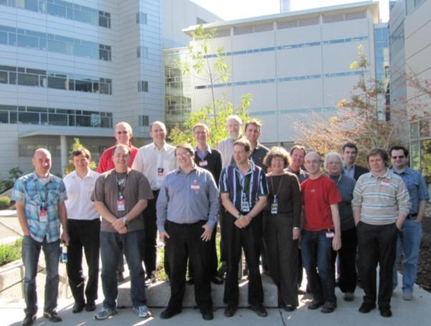

Testing

Automated Testing
The Mantid framework has an extensive test suite of 2,131 automated tests which are run on every code submission by all of the build servers (Windows 32, Windows 64, RHE, Mac OSX). Any failures are immediately emailed to all of the development team ensuring rapid feedback for any side effects their changes might have made. This provides good coverage of the framework itself.
The System Test suite tests user’s scripts and warns the development team if any change will affect the end results of common scripts.
The current system tests cover:
- Powder Diffraction (GEM & WISH)
- Direct & Indirect Inelastic Convert To Energy
- Polref data reduction
- Data Loading Raw Vs Nexus
- SANS: Analysis, Centre Finding, File summation, Batch Operation, Single Period No Trans
It is clear that we only have ISIS based system tests at the moment, something that we will need to correct.

Manual Testing
The manual testing approach that was introduced at the last PMB has proven to be very successful. The entire development team is involved in the testing of each release. During the development of iteration as each TRAC ticket is completed it moves onto an awaiting testing list. At the end of each iteration, the whole development team start selecting tickets from this list to test, but they must have not been involved in the tickets development themselves. This approach has several advantages:
- The whole development team have to talk to each other, promoting knowledge sharing
- It encourages developers to think about usability and what the users actually want to do
- Test coverage is much better in breadth and depth
- Robustness of the system is improved, every crash is investigated
- If one or two developers have to spend time fixing urgent issues it does not stop the testing process
- The development team can make the joint call to release, this increases ownership
- The testing process is tracked through the TRAC ticket system.
We have followed this approach for the last two releases, and it has proved to be a good way of encouraging communication between developers as well as testing the release well. For both releases we have not had any significant issues slip through testing. The testing period for both releases has been 3 days, which as a proportion of the overall iteration time is rather small (≈7%).

Project Metrics
SubProject | Files | Statements | %comments
Mantid Framework | 1396 (1057) | 153,950 (123,443) | 21.8 (20.4)
MantidPlot | 497 (445) | 89,685 (79.917) | 12.8 (11.2)
Total | 1893 (1502) | 243,635 (203,360)
I have changed what I report in this section, previously I reported the number of lines in the files, and while this is a greater number, it is misleading as it includes comments and whitespace. The metrics are defined as follows:
Metric | Description
Files | The number of .h, .cpp, .xml and .py files (not including third party libraries) included in the analysis.
Statements | The number of valid C++ statements, loops, conditional statements and pre processor directives are included.
% Comments | This the percentage of the overall number of lines which are comment lines. I have not directly reported the number of lines in the file, but a good rule of thumb is that it is roughly twice the number of statements.

Mantid Framework code has consistently grown since the last PMB (the previous values are in brackets), as would be expected with the addition of the new functionality described in section 3.1. The rate of increase to the MantidPlot code has once again picked up as we have added further visualization functionality.

Ticket completion rate
Development on Mantid is performed in two month iterations, each of which ends with an official release of the software. Longer pieces of work sometimes have to span a development iteration in which case that piece of work appears as completed only in the iterations when it becomes available to the users.
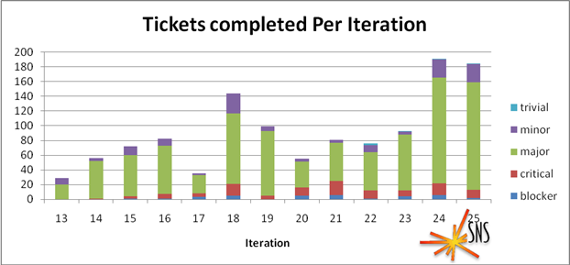
I have restricted the data to the last 12 iterations, with Iteration 24 and 25 being new since the last meeting of the PMB. The completion rate continues well, with a large increase in iterations 24 and 25 being due to ticket completed by staff at the SNS.

Project Uptake

Software Downloads
Our software download site currently requires people to register to a mailing list in order to download the installer packages, this primarily allows us to let users know when a new version is available, but also allow the project to monitor how many people have downloaded the software. A simple analysis of the email domains shows that while the majority of the users are from ISIS, followed by ORNL and we have had some interest from other institutions and universities.
The overall increase in subscribers has been much smaller this time, although much of this change is associated with a removal of duplicated and dead email addresses.
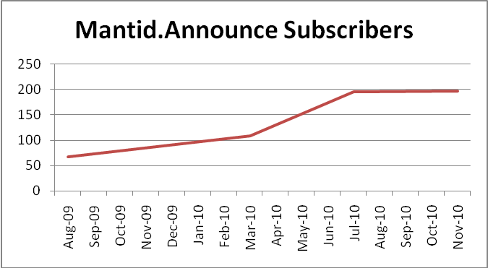
Summary
Date | Users
Aug-09 | 68
Mar-10 | 109
Jul-10 | 195
Nov-10 | 197

Current domain breakdown
domain | count
stfc.ac.uk | 60
ornl.gov | 20
gmail.com | 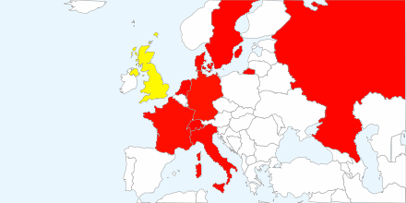  13
helmholtz-berlin.de | 7
swansea.ac.uk | 2
caltech.edu | 2
owlpic.com | 2
tudelft.nl | 2
risoe.dtu.dk | 2
ill.fr | 2
isc.cnr.it | 2
anl.gov | 2
uwstout.edu | 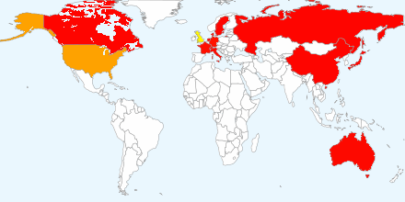  2
ansto.gov.au | 2
shef.ac.uk | 1
sheffield.ac.uk | 1
sms.ed.ac.uk | 1
imperial.ac.uk | 1
fysik.uu.se | 1
nf.jinr.ru | 1
live.com | 1
esrf.fr | 1
esss.se | 1
thorsbro.dk | 1
fi.isc.cnr.it | 1
usyd.edu.au | 1
dur.ac.uk | 1
chem.ox.ac.uk | 1
aber.ac.uk | 1
tempinbox.com | 1
cea.fr | 1
126.com | 1
bristol.ac.uk | 1
physics.org | 1
bellsouth.net | 1
uea.ac.uk | 1
ill.eu | 1
hotmail.com | 1
bath.ac.uk | 1
qmul.ac.uk | 1
mailinator.com | 1
psi.ch | 1
ed.ac.uk | 1
googlemail.com | 1
yahoo.com | 1
paxam.co.uk | 1
mcs.anl.gov | 1
warwick.ac.uk | 1
jaea.go.jp | 1
space-research.org | 1
mails.gucas.ac.cn | 1
mta.ca | 1
physics.ox.ac.uk | 1

Instrument usage

WISH
Mantid is now in use supporting all of the data reduction for powder diffraction on WISH, and the python scripting capability is being widely used to provide flexibility in analysis and to help support the large memory requirements of WISH data.
While the majority of powder diffraction data reduction is now supported for Mantid there are areas to further improve the software. These are primarily centred around improving the details of the Absorption correction to take into account the beam divergence and multiple scattering.
Currently WISH does not have any software to support single crystal data reduction and analysis, this is planned to be included within Mantid over the next 6 months.

GEM
Mantid is now providing all of the data reduction for GEM.

HRPD
Mantid is now providing all of the data reduction for HRPD.

MARI
Mantid is now in use performing the data reduction that was previously performed by Homer. Mantid is planned to be adopted for use on MAPS and MERLIN for after the long shutdown, and a shortlist of required features is being worked on.

SANS2D
Mantid is supporting all of the data reduction needs of SANS2D.

LOQ
Mantid can support all of the functionality of Collette. The decommissioning of Collette is being considered and a detailed analysis of the differences between Mantid and Collette is underway.

OFFSPEC
Data reduction on OffSpec is now exclusively carried out using Mantid.
In the coming months the Large Scale Structures group plan to implement a group wide code base that will allow the same data reduction scripts to be used on all five of the ISIS reflectometers. Tim Charlton will co-ordinate this effort with the eventual goal being to incorporate the code into the publically available release.

EXED (HMI)
Mantid is supporting the Data reduction needs of EXED at the HMI in Berlin.

POWGEN
The POWGEN diffractometer is now supported in Mantid including detector alignment.

ARCS, CNCS & SEQUIOA
Undergoing evaluation by instrument scientists.

GPSANS & BIOSANS
Undergoing evaluation by instrument scientists.

Supporting Mantid

Current Process
The current support procedures have not changed. The email address mantid-help@mantidproject.org is monitored by:
- Nick Draper
- Russell Taylor
- Stuart Campbell
- Martyn Gigg

Training
We have not held any further sessions of our Python or Mantid scripting training courses since the last PMB meeting.

Next 12 months
We expect over the next year we would expect the number of requests to roughly double as the SNS instruments adopt Mantid. We believe our current reporting mechanism can cope with this level of increase.

Financial review
Details of the project financial state are included in Appendix A. The current order with Tessella will end at the start of April 2011. The current contract will fall short of this target date by almost two months; this shortfall will need to be addressed by a small additional order from ISIS.
The initial order for Russell Taylor at ORNL is almost exhausted and need extending as soon as possible.

Citing Mantid
It has been agreed in the Mantid memorandum of understanding that we will define a method for citing the usage of Mantid in scientific papers. We had an initial discussion at the last meeting and have developed that a little further since then.

Approach
Within Mantid we have introduced and identified a number of unobtrusive but prominent locations where the citation details can be presented.
- An introductory welcome message, displayed in the MantidPlot log window, or on the console when starting Mantid from Python.
- The MantidPlot Help -> about window.
- The www.mantidproject.org home web page.
The approach we have been investigating is the use of Digital Object Identifiers [DoI] to refer to the prominent sections of Mantid. DoI’s are accepted widely in the scientific publishing community and allow easy searching for usage of the project using the web of science.

Mantid DoI’s
Mantid needs to support both a main DoI for the body of the framework, and will have a lot of contributors, but it also needs to have some more specific DoI’s for acknowledging the greater contributions of people in certain areas of the project. Clearly we would not want the number of specific DoI’s to get too high and this would need to be managed. I suggest the following initial separation as a starting point for discussion.
Mantid Framework
Owners: Nick Draper, [Entire development Team], [PMB Board members], Robert McGreevey or Laurent Chapon
VATES
Owners: Nick Draper or Owen Arnold, [VATES development Team], [PMB Board members], Toby Perring

Possibly an additional DoI for
Mantid Event based data handling
Owners: Nick Draper, [ORNL development Team], [PMB Board members], Mark Hagen

Immediate Priorities

Common

Python scripting improvements
The python scripting environment has proven to be popular at both ISIS and the SNS. Due to the widespread usage several areas for improvement have been identified:
- Adding a short list of operations directly to the workspace object
- Improve the naming of automatically generated workspaces from commands such as w1 = w1+w2
- Improve the auto completion and dynamic help for Mantid algorithms & workspaces
- Expose the remaining workspace objects to Python (Axes, Units)
- Improve the installation of Mantid within Python
- Upgrading the version of Python from 2.5
- Allowing the definition of curve fitting functions in python
These tasks will be split among Martyn Gigg, Russell Taylor, Mathieu Doucet and Michael Whitty.

2D view unwrapping and interaction improvements
At the last scientific steering committee the importance of providing a 2D unwrapped view was emphasised, in order to allow the instrument view to be useful beyond commissioning and diagnosis. Jon Taylor and Laurent Chapon have provided a list of requirements.
- http://svn.mantidproject.org/mantid/trunk/Documents/Requirements/Requirements%20for%20MANTID%20instrument%20view.docx
From this we have created and agreed several mock-ups of the suggested changes to the instrument view. These are being shared with SNS for feedback at the moment.
- http://svn.mantidproject.org/mantid/trunk/Documents/Design/Mockups/MantidPlot/Instrument-Render.bmml
- http://svn.mantidproject.org/mantid/trunk/Documents/Design/Mockups/MantidPlot/Instrument-Pick.bmml
- http://svn.mantidproject.org/mantid/trunk/Documents/Design/Mockups/MantidPlot/Instrument-Pick-lines.bmml
These are all created using the Balsamiq mock-up tool and can be viewed using to free web demo version. http://builds.balsamiq.com/b/mockups-web-demo/.
Roman Tolchenov has already made good progress on the plotting of the unwrapped instrument.

Masking improvements
Mantid has up until now supported a range of approaches for defining and handling detector masks that have come from the individual scientific groups. It has become clear that Mantid could handle this in a more consistent approach and provide better functionality to all of the scientific groups.
- Workspaces objects that define masks
- Supporting set operations on masks: union, intersection, inverse
- Mask visualization in the instrument view
Andre Savici, Martyn Gigg and Peter Peterson are working on these changes.

ISIS
Given the current restart date for ISIS being the 1st of March 2010 there are certain developments that are required in Mantid to support the planned experiments in the first cycle. Some of the changes are due to instrument upgrades, others are to support different types of experiments on the Mantid supported instruments, and others are to support the adoption of Mantid on new instruments.

MC absorption correction for multiple sample objects
This is desired by several beam lines in order to correctly account for the effect of various pieces of sample environment equipment, but it is absolutely essential for the Pearl beam line where the neutrons travel through the pressure anvils as well as the sample.
Good progress is being made in this area and a significant proportion of Martyn Giggs time has been ring fenced to work on this.
As there is a risk that the approach of building Monte Carlo facilities into Mantid could fail to deliver in the required time frame, we are also following a second approach of improving the integration between Mantid and McStas. Peter Willendrup is visiting the Mantid team on the 14th-15th of December.

Diffuse Scattering
In order to support the initial user program for WISH we need to be able to support the reduction required for diffuse scattering analysis. This involves the following new functionality in Mantid, although several of these requirements overlap with VATES requirements.
- Spatial Pixel Averaging to allow division by vanadium
- Automatic peak detection and indexing
- Calculation of the UB Matrix and crystal orientation
- Conversion of TOF data to Qx,Qy,Qz, intensity and error
Andre Savici, Janik Zikovsky, Alex Buts, Owen Arnold and Michael Whitty are working on adding this functionality, with scientific support from Laurent Chapon.

Direct Inelastic changes & evaluation
Two areas have been identified in the Direct Convert to Energy workflow that need to be improved for the ISIS start-up.
- Currently the masks for the White Beam run and the data run are not merged before applying to the data, leading to unexpected NaN and Inf values in the final data.
- A new diagnostic algorithm to account for bleeding in PSD tubes needs to be developed and integrated.
Martyn Gigg is working on implementing these changes.

SNS & HFIR

Direct Inelastic GUI integration
Several changes need to be made to support the file name, instrument differences and different workflow steps with the SNS instruments.
Most of this has now been completed by Stuart Campbell.

SNS Archive support
Mantid needs to be extended to be able to find files within the SNS archive when locally attached to the ORNL network.
Janik Zikovsky will work on this.

SNS metadata catalog integration
Mantid has been developed to allow integration with different back end data catalog implementations. At present only ICAT v3 is supported. Implementation of this support has been delayed while the SNS decided what system should be used as the information catalog. Recently the decision was made to use the VFS system developed by Mark Green. We need to build the interface between the two systems, to give SNS users similar quering and remote download support as they have at ISIS.
The resource for this has not yet been allocated.

Future requirements

ISIS: Requirements in the short, medium and long term
In August 2009 we conducted a requirements gathering exercise where we asked each of the groups present at the scientific steering committee to submit their requirements for Mantid over the following periods:
- Short: up to six months – Ending Feb 2010
These were all been completed by the deadline
- Medium: up to 18 months – Ending Feb 2011
Most of these have been implemented, those that have not are detailed in the immediate priorities section above.
- Long: 18 to 36 months – Ending Aug 2012
Several of these requirements are already being worked on.
  - Several: MC absorption correction with Multiple scattering
  - Excitations: Distributed computing graphics
  - Scientific Computing: Event based data support
The spreadsheet is available in the link below.
http://svn.mantidproject.org/mantid/trunk/Documents/Requirements/ShortMedLong%20Aug%2009.xls

SNS
The longer term plans at the SNS cover, although these will need review in the future:
- Integration of ISaw single crystal reduction and analysis into Mantid, allowing Topaz support.
- Parametric analysis of inelastic & single crystal data
- Increasing the support for further instruments at SNS and HFIR.
- Automated reduction: both batch mode and unattended reduction as the data comes off the instrument.
- Meta data driven reduction: Data capture and usage in automated reduction of the purpose of individual runs (e.g. sample, can, vanadium).
- Distributed data reduction and analysis: expanding the framework to support distributed processing of algorithms.

Future Release Dates
The planned release dates for the next six months are:
- 20th December 2010
- 18th February 2011
- 29th April 2011

Possible Collaborating With Other Facilities

Interest from other institutions

Reactor Sources

ILL
As a follow up to the visit of Andrew Harrison and Mark Johnson visited us on the 3rd February, they have contacted us to let us know they will be recruiting someone later this year to perform a 6 month evaluation of Mantid.

Pulsed Neutron sources

J-Parc
Masa Arai is interested in collaborating in some way, and is concerned that they may be left behind if they do not join in with Mantid in some way. Following a discussion with Toshiya Otomo and Mark Hagen at NOBUGS 2010 we have agreed to collaborate on a single small area to see how the collaboration may work.
We are going to try and agree on a single intermediate data format across the three institutions, ISIS, SNS and J-PARC. We have agreed to write and exchange white papers by Christmas. Following this we will discuss them and come to a consensus for us all to implement.

ESS
Stig Skelboe the Head of the Data Management Centre of the ESS is visiting Mantid at ISIS on the 14-15th of December.
“I think that the Mantid project is very interesting. I am not yet sure of the resources I'll have available for software development in the immediate future, but I think that we'll be able to contribute somehow to Mantid.”

Chinese SNS
Juzhou Tao is very interested in using Mantid at the CSNS. They have not broken ground on the facility yet, but are planning their data management and analysis structures now. As they are a new facility there are no legacy solutions in place and joining an existing collaboration with a solution for data reduction makes a lot of sense to them.
I have offered to train a Mantid lead developer for them at ISIS for 6 months if they can provide the travel and subsistence funding. Juzhou is considering this for next year, but currently thinks the only suitable person would be himself.
Given that I believe that China is considered to be s sensitive country at ORNL would there be any issues with the CSNS joining the collaboration in some way?

Others

DANSE
The DANSE team have been in touch and are eager to talk with us about effectively utilizing the software the DANSE has created at the NSSD and ISIS. They are interested in presenting and overview of the DANSE deliverables to the NSSD and Mantid team. I have suggested that in order to generate interest at ISIS it would be best for them to come and present at ISIS (in addition to the NSSD). Further email contact has suggested that he is interested in presenting some of their back end software frameworks as well as the derived software. I have a teleconference with Mike McKerns on Friday to discuss this further.

